1 Introduction 3

1.1 Motivation 3

1.2 How to simulate fluids 3

1.3 Related work 4

1.4 Used techniques 5

2 Fluid simulation 7

2.1 Chapter overview 7

2.2 Basics of fluid mechanics 7

2.3 Basics of smoothed particle hydrodynamics 12

2.4 Particle based, mathematical model of fluid motion 14

2.5 Smoothing kernels 17

2.6 Basic simulation algorithm 18

2.7 Implementation 20

2.8 Environment and user interaction 23

2.9 Multithreading optimisation 24

2.10 Results 25

2.11 Further work and outlook 26

3 Visualisation 29

3.1 Chapter overview 29

3.2 Target graphics-hardware and –APIs 29

3.3 Direct particle rendering 29

3.4 Isosurface rendering with marching cubes 30

3.5 Efficient volumetric density field construction 33

3.6 GPU-based isosurface raytracing 34

3.7 GPU-based volumetric density field construction 38

3.8 Rendering optical characteristics of water 38

3.9 Results 38

3.10 Improvements and alternatives 38

4 Conclusion 40

Appendix 41

References 41

Glossary 42

Derivation of the gradient and Laplacian of the smoothing kernels 42

# Introduction

## Motivation

Fluids like liquids and gases are ubiquitous parts of the environment we live in. For instance we all know how it looks like when milk gets filled into a drinking glass. In realtime computer graphics, where we traditionally try to reproduce parts of our world as visually realistic as possible, it is unfortunately hard to simulate such phenomena. Computational fluid dynamics is a relatively old and well known research topic, but most applications (like i.e. in aerodynamics research) aim at results that are as accurate as possible. Therefore, the simulations are mostly calculated offline and realtime visualisation – if at all - is used only to render precomputed data sets, if at all.

|  |  |
| --- | --- |
| 2.png  3.png  Figure 1: Example for offline simulation Source:[APK07] | 1.png  Figure 2: Example for realtime simulation Source: [MCG03] |

Realtime applications that do allow the user to interact with authentically (but not necessarily accurately) simulated and rendered fluids (like i.e. water) are rare today rare. For all types of virtual realities, like surgical training environments or computer games, there is always demand to cover more aspects of our world and so realtime simulation and rendering of fluids is an interesting field of study. In 2003, Müller, Charypar and Gross sparked additional interest in realtime fluid simulation, with a paper that proposed a relatively simple, particle-based fluid-model, which fits well for realtime applications [MCG03]. Since then many different aspects of realtime particle-based fluid simulation where covered in a couple of papers from authors around the world. This thesis gives an overview on the topic, as it discusses my implementation of a particle-based fluid simulation and a suitable water renderer.

## How to simulate fluids

In the 19th century Claude Navier and George Stokes created the fundamentals of modern fluid dynamics as they formulated the well-known Navier-Stokes equations. With these equations, which describe the conservation of momentum, together with two additional equations for mass and energy conservation, it is possible to simulate the fluid flow. As the formulas tend to get very complicated for less common fluids, they are mostly written for Newtonian fluids, which include a variety of common liquids and gases (water, air...).

Simulations apply numerically methods to solve the - in most cases - resulting non-linear partial differential equations. One common way to do this is to treat the fluid as a continuum, discretize the spatial domain into a grid and use finite differences or the finite volume method. In the literature grid-based fluid models are called Eulerian models. For the use within virtual environments grid- based methods, as a matter of principle, have the drawback of a bounded simulation space.

In contrast, particle-based methods (in literature: Lagrangian model, from Lagrangian mechanics) represent the fluid as a discrete set of particles and simulate the fluid flow through solving the particle dynamics. For realtime applications this results in some advantages versus grid-based methods:

* simpler calculation (mass conservation can be omitted, convective term can be omitted, cp. [MCG03])
* no numerical diffusions in the convection terms (diffusion directions are not influenced by the grid layout)
* surface reconstruction is likely to be easier
* fluid can spread freely in space (no boundary through the grid)

For these reasons (especially the last) this thesis focuses on a Lagrangian method based on smoothed particle hydrodynamics (SPH) [Mon05], which became very popular for this kind of applications. The idea behind SPH is that every particle distributes the fluid properties in its neighbourhood using radial kernel functions. To evaluate some fluid property at a given point one must simply sum up the properties of the neighbouring particles, weighted with the appropriate smoothing function.

## Related work

The first studies of smoothed particle hydrodynamics where made in 1977 by Gingold and Monaghan (who coined the term) [GM77] and independently by Lucy [Luc77]. Its first usages took place mainly in the astronomy sector to simulate large scale gas dynamics, but later it also has been applied to incompressible flow problems like beach wave simulation, sloshing tanks and bow waves of ships.

While in realtime computer graphics first the Eulerian approach was favoured, Müller, Charypar and Gross [MCG03] where one of the first who showed, that a SPH based Lagrange method also suits very well to interactive applications. Later many papers used SPH to simulate fluids (especially liquids) in realtime and brought adaptations and improvements both for the simulation as well as for the rendering of liquids.

Papers on realtime SPH simulation:

* [KC05] proposes to avoid the particle neighbourhood problem by sampling the fluid properties from grids that sum up the weighted properties from all particles
* [KW06] compares the performance of an octree-based (linear time for neighbour search, but large costs for the update of the structure) versus a “staggered grid”-based solution to the neighbour problem
* in [MST04] Müller et al. show how particle-based fluids can interact with deformable solids
* [AIY04] sketches how to use a CPU generated neighbour map so that the property summation for each particle can be handled on the GPU, which reaches twice the performance of their CPU only simulation
* [Hei07] uses the Ageia PhysX engine (one of its developers is Matthias Müller) for a SPH-based simulation of smoke

Papers with relevance for realtime liquid rendering:

* [MCG03] suggests direct point splatting of the particles or marching cubes rendering [LC87] of the isosurface (which implies the creation of a volumetric density field for each frame)
* [KW03] presents a GPU executed raycaster for volumetric scalar fields; in combination with a efficient method for building the density field on the GPU this way the isosurface could be visualized
* [CHJ03] introduces iso-splatting, a point-based isosurface visualisation technique; same as with [KW03] applies here
* [Ura06] demonstrates a GPU version of the marching tetrahedra algorithm (variation of marching cubes); same as with [KW03]
* [KW06] uses a 2.5D “carped visualisation” for the special case of rivers and lakes

## Used techniques

The goal of this thesis is to provide a realtime application that simulates a water-like liquid in a form that is “believable” in terms of movement behaviour and optical appearance. The SPH simulation, therefore, focuses not on physical accuracy. It’s a straightforward implementation of the lightweight SPH model presented in [MCG03], optimized to run on actual multi-core consumer CPUs. To speed up the neighbour search it stores the particles according to their position in a dynamic grid, with a cell size equivalent to the maximal radius of support. The particle interactions are evaluated directly on pairs of particles (simultaneous for both particles). Chapter 2 discusses the theoretical foundations and the implementation details of the simulation.

For visualisation three techniques are provided: The first directly renders the particles as point sprites, which is mainly useful for debug and tuning of the fluid behaviour. The second, which is nearly entirely CPU-based, uses the marching cubes algorithm to construct a triangle mesh representing the isosurface. This technique was implemented to experiment with efficient density field construction methods and to test how well a marching cubes- / triangle-based approach fits for the purpose of liquid visualisation. The last and most sophisticated technique uses the GPU to construct a volumetric density field within a 3D texture and renders the isosurface directly with a ray-tracing shader. The ray-tracing enables the visualisation of effects like multiple refractions and reflections, which are characteristic for the optical appearance of liquids. Chapter 3 explains each visualisation technique in detail.

|  |  |  |
| --- | --- | --- |
| 1.jpg  Figure 3: Sprite visualisation | 2.jpg  Figure 4: Marching cubes visualisation | 3.jpg  Figure 5: GPU ray-tracing visualisation |

# Fluid simulation

## Chapter overview

This chapter discusses realtime particle based simulation of fluid movement, even though other aspects of fluid behaviour (i.e. heat convection) could also be described with the methods presented here. The simulation written for this thesis shall provide a solid basis for the development of realtime visualisation methods for particle based liquid simulations and comprehensible exemplify the implementation of fluid simulations for interactive applications. Therefore, its focus is not on physical accuracy or cover of as much scenarios as possible, but on a clear, simple and highly efficient implementation.

The description of realtime fluid simulation based on SPH starts with an introduction to some basic concepts of fluid mechanics in 2.2. This subchapter clarifies the meaning of the most important simulation quantities and illustrates the differences between the Eulerian and Lagrangian point of view, while it briefly derives the Navier-Stokes equation from Newton’s second law of motion. It should not be understood as mathematic derivation, but rather as an attempt to help the reader to comprehend the meaning of the equation.

After the introduction to fluid mechanics in general, 2.3 explains the core concepts of smoothed particle hydrodynamics, which are applied to the Navier-Stokes equation in 2.4 to develop the mathematical model on which the fluid simulation is based. After a short introduction of the used smoothing kernels in 2.5, the conceptual simulation algorithm is presented in 2.6, which is the basis of the implementation that is discussed in 2.7.

In 2.8 the implementation is made capable to interact with the environment and the user, while 2.9 discusses how multithreading could be used to gain more performance on today’s CPUs. The results section 2.10 shows how well the final program fulfils its task in terms of performance and simulation quality. 2.11, the last section in the chapter, discusses further improvements that could be made to the existing simulation and gives an outlook on technologies, from which the realtime simulation of fluids could benefit.

## Basics of fluid mechanics

Fluid mechanics normally deals with macroscopic behaviour at length and time scales where intermolecular effects are not observable. In this situation fluids can be treated as continuums where every property has a definite value at each point in space. Mathematically this can be expressed through functions that depend on position and time (i.e. vector or scalar fields). Properties are macroscopic observable quantities that characterize the state of the fluid.

### Fluid quantities

The most relevant properties for the movement of fluids are mass, density, pressure and velocity. The mass specifies “how much matter there is” and is relevant for the inertia of the fluid. The mass density measures the mass per volume and is defined as:

|  |  |  |
| --- | --- | --- |
|  |  |  |

: very small length, but significant greater than the molecule spacing; : volume

Pressure is a scalar quantity that’s defined as the force acting in normal direction on a surface (normal stress): . Differences in the pressure field of a fluid (= force differences) result in a flow from areas of high to areas of low pressure, while in regions with constant pressure those forces are balanced.

The velocity is a measure for how fast and in which direction the fluid passes a fixed point in space. It is perhaps the most important property of the fluid flow. The velocity field effects most other properties either directly (i.e. dynamic pressure) or indirectly (i.e. because of advection). In viscous fluids (all real fluids are viscous to some amount) it is also relevant for the viscosity forces, which are together with pressure forces the most relevant fluid forces.

Viscosity compensates the differences in flow velocity over time (comparable to friction). In case of a fluid with a “constant” viscosity (later more on this topic) it is a measure for how much momentum is transferred between adjacent regions with different flow speeds and is thereby responsible for shear stress (tangential force on a surface). Viscosity as a constant is stated as dynamic viscosity (when the result is a force) or kinematic viscosity (when the result is acceleration).

Surface tension is the last cause of forces that we deal with. It is a property of the surface of the fluid (the border to another immiscible fluid, a solid or vacuum) that is relevant for the size of the forces that try to minimize the area and curvature of the surface. A simple explanation for the cause of surface tension is that the cohesive forces (attractive forces between molecules of the same type) between molecules on the surfaces are shared with less neighbour molecules than in the inner of the fluid, which results in a stronger attraction of the molecules on the surface. It is mentioned here for completeness although it is not further discussed in the basics subchapter (we will deal with it later in 2.4).



Figure 6: Cause of surface tension

### From Newtonian- to fluid mechanics

Now that we know the meaning of most magnitudes, let’s see how the motion of a fluid could be described mathematically. Let’s start with Newton’s second law:

|  |  |  |
| --- | --- | --- |
|  |  |  |

Note: vectors are written in bold (), scalars in italics ().

It states that the acceleration of an object depends on its mass and the force that acts on it. This could also be interpreted as conservation of momentum: Without external forces () there is no change of velocity () and the momentum stays constant.

In classical (Newtonian) dynamics Newton’s second law is usually interpreted from the Lagrangian point of view, meaning that a moving object is observed. With fluids this would mean that the observation area follows the fluid flow, so that always one and the same “amount of fluid” is being watched. Alternatively in the Eulerian point of view the area of observation is locally fixed, so that the fluid passes by and the watched amount of fluid may be a different one at each moment. The Eulerian observer, therefore, not only sees changes due to variances in the currently watched amount of fluid, but also changes due to the fact that the watched amount of fluid may be a different one every moment.



Figure 7: Lagrangian versus Eulerian point of view

In an Eulerian description (which is more common in classical fluid dynamics) the acceleration, therefore, must be a special time derivative of the velocity that takes into account the movement of currents in fluids in both of it forms: Diffusion and advection (together: convection). It is called substantial derivative (synonyms: substantive d., convective d., material d.) and defined as follows:

|  |  |  |
| --- | --- | --- |
|  |  |  |

written in Cartesian coordinates in three dimensions; : del operator; : components of velocity; : components of position; : an arbitrary quantity (vector or scalar)

The partial derivative expresses the “local” changes in the currently observed amount of fluid (i.e. due to diffusion or external influences) while the term represents the changes due to advection (transport of properties together with the matter). By replacing the acceleration in with the substantive derivative of the velocity we get:

|  |  |  |
| --- | --- | --- |
|  |  |  |

: gradient of the velocity (the Jacobian matrix)

(2.1) states that the mass of the fluid inside the observed control volume depends on its density, therefore we write:

|  |  |  |
| --- | --- | --- |
|  |  |  |

Now we will focus on the forces acting on the fluid. It can be distinguished between internal forces produced by the fluid itself and external forces like gravity or electromagnetic forces:

|  |  |  |
| --- | --- | --- |
|  |  |  |

The most important external force is gravity **,** which is in fact stated as gravitational acceleration. Synonymously we will describe the external forces as force density field that directly specifies acceleration (remember that the mass depends on the density in our case):

|  |  |  |
| --- | --- | --- |
|  |  |  |

In order to provide a simple expression for the fluid forces, we assume that we deal with a Newtonian fluid that satisfies the incompressible flow condition. A viscid fluid is called Newtonian when the viscous stress is proportional to the velocity gradient (cp. [Pap99]). For Newtonian fluids the equation describes the relation between shear stress , dynamic viscosity constant and the velocity gradient perpendicular to the direction of share [BE02]. This means in common words that, in contrast to non-Newtonian fluids, the viscosity is a constant and does not change under different shear rates. The fluid flow is called incompressible when the divergence of the velocity field is zero (), meaning that there are no sources or sinks in the velocity field. As a counter example think of air that expands because it is heating up. Note that also flows of compressible fluids (all real fluids are compressible to some extent) can satisfy the incompressible flow condition (i.e. regular air flow till ~ mach 0.3). If the fluid fulfils all this conditions, we can simply spilt fluid forces into forces due to pressure differences (normal stresses) and in viscosity forces due to velocity differences (shear stresses):

|  |  |  |
| --- | --- | --- |
|  |  |  |

The pressure forces depend only on the *differences* in pressure and let the fluid flow from areas of high to areas of low pressure. We model them with the negative gradient of the pressure field , which points from high to low pressure areas and has a magnitude proportional to the pressure difference:

|  |  |  |
| --- | --- | --- |
|  |  |  |

Because of our assumption of an incompressible flow, the viscosity force becomes a relatively simple term:

|  |  |  |
| --- | --- | --- |
|  |  |  |

: dynamic viscosity; : the Laplacian operator, sometimes also written

For a mathematical derivation of the term above see i.e. chapter 5 in [Pap99] or [WND]. Here it should only be remarked, that the Laplacian is an operator that measures how far a quantity is from the average around it and therefore the force expressed by (2.10) smoothes the velocity differences over time. This is what viscosity is supposed to do. By combining the last two formulas we end up with the Navier-Stokes momentum equation for incompressible, Newtonian fluids often simply referred to as *the* Navier-Stokes equation:

|  |  |  |
| --- | --- | --- |
|  |  |  |

Navier-Stokes equation

This equation is the basis of a bunch of fluid simulation models. In 2.4 we will combine it with the basic principles of smoothed particle hydrodynamics (2.3) to form the mathematical model of the fluid simulation presented in this thesis. The sense of its rather descriptive derivation in this subchapter was to make the equation plausible in each of its parts and as a whole. The derivation, therefore, was intentional not mathematically strict and left out some concepts that are relevant for other forms of the equation (like the stress tensor ). In the literature (i.e. [Pap99]) numerous mathematical strict derivations can be found if needed. This subchapter made clear that the Navier-Stokes equation is simply a formulation of Newton’s second law and a statement of momentum conservation for fluids.

## Basics of smoothed particle hydrodynamics

Smoothed particle hydrodynamics is a technique developed by Gingold and Monaghan [GM77] and independently by Lucy [Luc77] for the simulation of astrophysical gas-dynamics problems. As in other numerical solutions to fluid dynamic problems, the value of a physical quantity at a given position must be interpolated from a discrete set of points. SPH derives from the integral interpolation:

|  |  |  |
| --- | --- | --- |
|  |  |  |

is a radial symmetric smoothing function (also called kernel) with smoothing length (also called core radius). One could say that the interpolation uses the smoothing kernel to spread a quantity from a given position in its surroundings. In practice the kernel is even () and normalised () and tends to become the delta function for tending to zero (if would be the delta function, would reproduce exactly). This thesis follows the example of [MCG03] to treat as the radius of support, so all used smoothing functions will evaluate to zero for .

1.wmf

Figure 8: 1D example for a smoothing kernel

With SPH, a Lagrangian method, the interpolation points are small mass elements that are not fixed in space (like the grid points in the Euler method) but move with the fluid. For each such fluid particle a position , velocity , mass and density is tracked. The value of a quantity at a given position can be interpolated from the particle values using the summation interpolant (derived from the integral form):

|  |  |  |
| --- | --- | --- |
|  |  |  |

The mass-density-coefficient appears because each particle represents a volume of . As an interesting example (2.13) applied to the density gives:

|  |  |  |
| --- | --- | --- |
|  |  |  |

Which shows that with SPH the mass density is estimated by smoothing the mass of the particles.

In practice not all particles must participate in the summation. As the smoothing kernel only has a finite radius of support, all particles with a greater distance to the evaluated point can be omitted.

An advantage of SPH is that spatial derivatives (which appear in many fluid equations) can be estimated easily. When the smoothing kernel is differentiable the partial differentiation of (2.13) gives:

|  |  |  |
| --- | --- | --- |
|  |  |  |

The gradient, therefore, becomes:

|  |  |  |
| --- | --- | --- |
|  |  |  |

According to [MCG03] this could also be applied to the Laplacian:

|  |  |  |
| --- | --- | --- |
|  |  |  |

There also exist some different SPH formulations for the gradient and Laplacian that will not be further discussed here. Chapter 2.2 in [CEL06] gives a good overview of other useful formulations. Monaghan also suggests alternatives to (2.17) in chapter 2.3 of [Mon05].

This rules cause some problems when they are used to derive fluid equations for particles. The derivate does not vanish when is constant and a number of physical laws like symmetry of forces and conservation of momentum are not guaranteed. When the time has come, we will therefore have to adjust the particle fluid equations slightly to ensure physical plausibility.

## Particle based, mathematical model of fluid motion

Now the core concepts of SPH from 2.3 will be applied to the Navier-Stokes equation introduced in 2.2 in a straightforward way, to form a mathematical model for particle based fluid simulation that is simple enough to be suitable for realtime usage. This subchapter is entirely based on the [MCG03] paper, which introduced the lightweight simulation model used in this thesis.

In the model presented here each particle represents a small portion of the fluid. The particles carry the properties mass (which is constant and in this case the same for all particles), position and velocity. All other relevant quantities will be derived from that using SPH rules and some basic physical equations.

Grid-based Eulerian fluid models need an equation for the conservation of momentum like the Navier-Stokes equation (2.11) and at least one additional equation for conservation of mass (sometimes one for energy conservation too) like the continuity equation:

|  |  |  |
| --- | --- | --- |
|  |  |  |

Continuity equation

The mass of each particle and the count of particles are constant, so mass conservation is guaranteed automatically. Hence, the momentum equation is all that is needed to describe the movement of the fluid particles in our model. Furthermore, a Lagrangian model doesn’t have to take advection of currents into account (see the comparison in 2.2) and thus the substantial derivative of the velocity field in the Navier-Stokes equation can be replaced with an ordinary time derivative of the particle velocity. What we get is a momentum equation for a single fluid particle:

|  |  |  |
| --- | --- | --- |
|  |  |  |

: force acting on particle   
: density at position of particle   
: pressure gradient at position of particle   
: velocity Laplacian at position of particle

For the acceleration of a particle we get therefore:

|  |  |  |
| --- | --- | --- |
|  |  |  |

In (2.14) we have already seen how we could calculate the density at the particles position using the SPH rule (2.13):

|  |  |  |
| --- | --- | --- |
|  |  |  |

The external force density field rightmost in (2.19) directly specifies acceleration when the density factor vanishes after the division in (2.20). All what is left for a complete description of the particle movement based on the Navier-Stokes equation are the terms for pressure and viscosity forces.

### Pressure

According to the SPH rules the pressure term would look like as follows:

|  |  |  |
| --- | --- | --- |
|  |  |  |

Unfortunately the resulting force is not symmetric. This could be easily seen when only two particles interact. Because the gradient of a radial smoothing kernel is zero at its centre, particle only uses the pressure of particle and vice versa. The pressure varies at different positions and thus the pressure forces would be different for the two particles. [MCG03] suggests balancing of the forces by using the arithmetic mean pressure of the two interacting particles:

|  |  |  |
| --- | --- | --- |
|  |  |  |

Till now the pressure at the particle positions was an unknown. Müller et al. propose to use the ideal gas state equation to derive the pressure directly from the density:

|  |  |  |
| --- | --- | --- |
|  |  |  |

: gas constant depending on temperature; : rest density

### Viscosity

Applying the SPH rule to the viscosity term yields the following equation:

|  |  |  |
| --- | --- | --- |
|  |  |  |

This again results in asymmetric forces for two particles with different velocities. The viscosity forces depend only on velocity differences, not on absolute velocities; therefore the use of velocity differences is a legitimate way of balancing the force equation:

|  |  |  |
| --- | --- | --- |
|  |  |  |

This means the viscosity force in our model accelerates a particle to meet the relative speed of its environment.

### Surface tension

Now we have a simple model for the forces acting on the particles that contains everything what is expressed by the Navier-Stokes equation. But there is an additional fluid force relevant for the scenario we would like to describe, which is not covered by the momentum equation. Fluids interacting with solid environments often produce small splashes and puddles with much free surface, where the surface tension force plays a noticeable role. As described in 2.2 the surface tension forces try to minimize the surface of the fluid body, to achieve an energetically favourable form. The bigger the curvature of the surface is, the bigger should be the surface tension forces that push the border particles towards the fluid body. In order to find the particles at the surface and calculate the surface tension forces, the colour field method is used in [MCG03]. A colour field is 1 at particle positions and 0 everywhere else. The smoothed colour field has the form:

|  |  |  |
| --- | --- | --- |
|  |  |  |

The gradient of the color field gives us two kinds of information: Its length becomes huge only near the surface, which helps us identifying surface particles and its direction points towards the centre of the fluid body, which is a good choice for the direction of the surface force. The surface curvature, which is a magnitude for the size of the force, can be expressed by the Laplacian of the colour field:

|  |  |  |
| --- | --- | --- |
|  |  |  |

Using the colour field gradient as force direction and “marker” for surface particles and the curvature as magnitude for the force size leads to the following equation for the surface tension force:

|  |  |  |
| --- | --- | --- |
|  |  |  |

: surface tension coefficient; depends on the materials that form the surface

is near to zero for inner particles, so the surface tension is only getting evaluated when it exceeds a certain threshold to avoid numeric problems. It should be mentioned that this surface tension model can be error-prone under some circumstances, so also other models proposed in the literature (i.e. in [BT07]) may be worth an evaluation.

## Smoothing kernels

The smoothing kernels used in the interpolations have great influence on speed, stability and physical plausibility of the simulation and should be chosen wisely. As every kernel is radial symmetric, it is normally specified only as function of the length of : . It should be even (), normalised () and differentiable as often as needed. Despite of these requirements one is free to specify the kernel in every form that is suitable for its task. In the literature there exist many different ways to specify them, from splines, over exponential functions up to Fourier transformation generated kernels. [Mon05] contains a good overview of the most common techniques.

In this thesis the kernels proposed in [MCG03] are used. The first is the Poly6 kernel:

|  |  |  |
| --- | --- | --- |
|  |  |  |

with:

it has the gradient:

|  |  |  |
| --- | --- | --- |
|  |  |  |

and the Laplacian:

|  |  |  |
| --- | --- | --- |
|  |  |  |

Note that in the appendix there is the section “Derivation of the gradient and Laplacian of the smoothing kernels”

Its advantage is that appears only squared, so the computation-intense calculation of square roots can be avoided. The Poly6 kernel is used for everything except the calculation of pressure and viscosity forces. With pressure forces the problem is that the gradient goes to zero near the centre. Therefore, the repulsive pressure force between particles vanishes when they get too close to each other. This problem is avoided by the use of the Spiky kernel, which has a gradient that does not vanish near the centre:

|  |  |  |
| --- | --- | --- |
|  |  |  |

Gradient:

|  |  |  |
| --- | --- | --- |
|  |  |  |

With viscosity the problem of the Poly6 kernel is that its Laplacian becomes negative really fast. A particle that is faster than its environment may therefore be accelerated by the resulting viscosity forces, while it should actually get slowed down. In the viscosity calculation thus the “Viscosity” kernel is used, which’s Laplacian stays positive everywhere:

|  |  |  |
| --- | --- | --- |
|  |  |  |

Gradient:

|  |  |  |
| --- | --- | --- |
|  |  |  |

Laplacian:

|  |  |  |
| --- | --- | --- |
|  |  |  |

|  |  |  |
| --- | --- | --- |
| ip.eps | is.eps | iv.eps |

Figure 9: Used smoothing kernels

(from left to right) along the x-axis for   
thick lines: kernel, thin l.: absolute value of gradient, dashed l. Laplacian

## Basic simulation algorithm

Subchapter 2.4 described how the fluid forces acting on the particles could be derived directly from the particle positions and velocities. This enables us to specify the basic algorithm for the fluid simulation:

Listing 1: Basic simulation algorithm

|  |
| --- |
| **while** simulation is running  h ← smoothing-length  init density of all particles  clear pressure-force of all particles  clear viscosity-force of all particles  clear colour-field-gradient of all particles  clear colour-field-laplacian of all particles  *// calculate densities*  **foreach** particle **in** fluid-particles  **foreach** neighbour **in** fluid-particles  r ← position of particle **–** position of neighbour  **if** length of r **≤** h  **add** mass **\*** W_poly6(r, h) **to** density of particle *// compare*  **end-if**  **end-foreach**  **end-foreach**  *// calculate forces and colour-field*  **foreach** particle **in** fluid-particles  **foreach** neighbour **in** fluid-particles  r ← position of particle **–** position of neighbour  **if** length of r **≤** h  density-p ← density of particle  density-n ← density of neighbour  pressure-p ← k **\*** (density-p **–** rest-density) *//*  pressure-n ← k **\*** (density-n **–** rest-density)  **add** mass **\*** (pressure-p **+** pressure-n) **/** (2 **\*** density-n) *//*  **\*** gradient-W-spiky(r, h) **to** pressure-force of particle  **add** eta **\*** mass **\*** (velocity of neighbour **–** velocity of particle)  **/** density-n **\*** laplacian-W-viscosity(r, h)  **to** viscosity-force of particle *//*  **add** mass **/** density-n **\*** gradient_W_poly6(r, h)  **to** colour-field-gradient of particle  **add** mass **/** density-n **\*** laplacian_W_poly6(r, h)  **to** colour-field-laplacian of particle  **end-if**  **end-foreach**  **end-foreach**  *// move particles*  **foreach** particle **in** fluid-particles  gradient-length ← length of colour-field-gradient of particle  **if** gradient-length **≥** threshold *//*  surface-tension-force ← -sigma **\*** colour-field-laplacian of particle  **\*** colour-field-gradient of particle **/** gradient-length  **else**  surface-tension-force ← 0  **end-if**  total-force ← surface-tension-force **+** pressure-force of particle  **+** viscosity-force of particle  *//*  acceleration ← total-force **/** density of particle **\*** elapsed-time + gravity  **add** velocity of particle **+** acceleration **\*** elapsed-time  **to** velocity of particle  **add** velocity **\*** elapsed-time **to** position of particle  **end-foreach**  **end-while** |

The dependencies on the density and the forces lead to a tripartite evaluation scheme. First the density of each particle is evaluated by summation over the contributions of all particles in the neighbourhood. In the second step every neighbour exerts forces on the particle and the colour field is being built. At last the accumulated forces are used to approximate the movement of the particles in the current time step.

## Implementation

The fluid simulation as well as whole other CPU code of the program was implemented with C++, because today it is the de facto standard in professional, realtime computer graphics on PCs. The pseudo code in the last chapter describes the real implementation of the simulation component relatively well. The update method that is called once for every simulation step, indeed linearly executes the following four tasks:

calculate density at every particle position

calculate pressure forces, viscosity forces and colour field values for each particle

move the particles and clear the particle related fields

update the acceleration structures

As stated before the particles carry only the properties position and velocity (the mass is constant and the same for all particles). This is the only information that is transferred from one simulation step to the next. All other per-particle data, like density and forces is stored in separate arrays. The particle data structure, therefore, consists of one three-component vector for position, one for velocity and an integer index that locates derived particle properties in the respective arrays.

The first task, the density calculation, has to implement the summation interpolation. The summation is the most crucial point for the overall performance of the simulation. The naive summation over all particles in the simulation would result in a computation complexity that is quadratic in the number of particles, which is impracticable for the amounts of particles we aim at. Therefore, it is necessary to implement the summation as a neighbour search that finds all neighbour particles that are near enough to influence a certain particle. Those are all particles with a distance lower than their radius of support (= smoothing length in our case). In this simulation the smoothing length is treated constant and equal for all particles.

### Neighbour search

This allows the use of a location grid as efficient acceleration structure for the neighbour search. The grid consists of cubic cells with a side length equal to the smoothing length. Each cell contains a reference to a list of all particles that map to the space partition associated with the cell or a null pointer, if no such particle exists. The particle positions change with every simulation step. Thus after each step the grid location and cell count dimensions must be updated to fit the space occupied by the particles and the particles must be sorted into the grid again.

The neighbour search finds the neighbours of all particles in a particular grid cell. Because the side length equals the smoothing length, all neighbouring particles must be contained in the current or one of the maximal 26 adjacent cells. This reduces the time complexity of the summation from to ( being the average number of particles per grid cell) at the cost of the time needed to rebuild the grid ().



Figure 10: Grid based neighbour search

A further performance gain is accomplished through storing copies of the particles in the grid cells instead of references. This dramatically lowers the cache miss rate of the CPU, because all particles that are accessed during the neighbour search for particles within one cell lie close to each other in system memory.

### Exploitation of symmetry

The neighbour relation between the particles is symmetric () and also the interactions between the neighbors (density accumulation, force exertion) are mostly symmetric. This allows another optimisation: Whenever a particle pair contained in the neighbour relation is found, all necessary calculations are performed in both directions, so that every pair must be evaluated only once. The algorithm visits cell after cell. First it checks each particle against all that follow in the same cell. Then it checks all the pairs between the current cell and one half of the neighbour cells. If all neighbouring cells would be considered, the whole algorithm would evaluate each cell-neighbourhood twice. Thus all cells that are located on the opposite site of already checked cells are skipped (see Figure 11). In this manner the algorithm halves the computation complexity and ensures that every pair is found exactly once. The optimisation also has the consequence that no particle gets evaluated against itself, which is all right when the density initialisation takes care of the self induced density (for the forces and the colour field gradient/Laplacian this doesn’t matter at all).

|  |  |
| --- | --- |
| neighbour offsets  in 3D case:  ----↓---- ----↑----  (-1,-1,-1) ( 1, 1, 1)  (-1,-1, 0) ( 1, 1, 0)  (-1,-1, 1) ( 1, 1,-1)  (-1, 0,-1) ( 1, 0, 1)  (-1, 0, 0) ( 1, 0, 0)  (-1, 0, 1) ( 1, 0,-1)  (-1, 1,-1) ( 1,-1, 1)  (-1, 1, 0) ( 1,-1, 0)  (-1, 1, 1) (1,-1,-1)  ( 0,-1,-1) (0, 1, 1)  ( 0,-1, 0) (0, 1, 0)  ( 0,-1, 1) (0, 1,-1)  ( 0, 0,-1) (0, 0, 1)  **( 0, 0, 0)**→**( 0, 0, 0)** |  |

Figure 11: Skip neighbour cells on the opposite side

The density calculation is not the only task where the summation interpolation and therefore the neighbour search must be performed. In the separate force and colour field calculation the same neighbourhood relations are needed. Therefore, the particle pairs that are found by the neighbour search during the density computation phase are stored and reused within the following force and colour field stage.

The neighbour search delivers us all particle pairs with a distance below the smoothing length. The C++-method for the density computation calculates the additional density that the two particles impose on each other () and ads it to the total densities of both particles.

Similar the pressure force, viscosity force, colour field gradient and colour field Laplacian calculations in the second task first compute a common term for both particles according to the appropriate SPH equation. The term gets weighted with the density inverse of the neighbour particle (which is part of all four related SPH equations) and provided with the right direction (in case of a vector) before it is added to the particles overall values.

### Calculation of movement

After the first two tasks have pair wise evaluated the density, pressure force, viscosity force and the colour field values of every particle, the third task processes the particles linearly. The colour field gradient and Laplacian is used to calculate the surface tension force, which ads up with pressure and viscosity forces to the total per-particle force in the current time step. Total force divided by mass density results in an acceleration (Newton’s law), which is added to the constant earth acceleration to get the total acceleration. Combined with current velocity, position and step duration it finally leads to the new velocity and position of our particle at the end of the current simulation step, respectively the beginning of the next. Because position and velocity are the only information that is kept for the next step, all the other property fields get cleared/initialized at the end of the calculation.

The fourth and final step clears the neighbour search grid and rebuilds it from the new particle positions. For that purpose first the new spatial dimensions of the particle cloud are calculated and a properly placed and scaled empty grid is created. Then particle after particle gets sorted into the grid according to its position, whereby new cells are created on demand if a particle falls to a position where no cell exists yet.

## Environment and user interaction

A fluid floating around in empty space is rather untypically in our everyday environment. Thus we want to simulate interaction of the fluid with solid obstacles or containers. Moreover, the name suggests that an interactive realtime simulation should provide some sort of user interaction with the simulated object. Therefore, a liquid fluid has been placed in a virtual water glass that the user can move around with the mouse. This scenario is comparatively easy to simulate and because the fluid cannot flow away, the user gets a steady simulation that he can interact with over a long time. Additionally surely everyone once watched his drink when it is shaken around in the glass and thus we know very well how the fluid would behave in reality.

The environment interaction in this simulation works only in one direction, meaning that the movement of the simulated glass is entirely controlled by the user with the mouse and the fluid does not exert forces on the glass that would cause it to move. Conceptually the glass is modelled as an infinite long, vertical aligned cylinder as side walls and a horizontal aligned plane as ground of the glass. The collision detection, therefore, becomes a simple check of the particles distance from the cylinders centre line, respectively from the bottom plane. A first implementation of the glass interaction only checked if a particle was outside the glass and repositioned it back into the glass along the border normal. However, this does not lead to any physical plausible results, because thus the glass does not influence the fluid density near the border, nor does it participate in the pressure and viscosity computation. The actual implementation simulates the interaction of the glass with the fluid particles with the same SPH methods that are responsible for the particle-particle interactions. Therefore, synonym to the density and forces calculation phases for the fluid itself, extra density and forces calculation phases for the glass have been added to the simulations update method. Thus, a simulation update is now performed in six steps:

1. update densities (particle <-> particle)
2. update densities (glass -> particle)
3. update pressure forces, viscosity forces and colour field (particle <-> particle)
4. update pressure and viscosity forces (glass -> particle)
5. move particles, enforce glass boundary, clear fields
6. update the neighbour search grid

Because in some extreme situations the glass emitted pressure forces are not sufficient to keep the particles inside the glass, the fluids move-method (step 5) was equipped with a modified version of the old collision response code. It ensures that the particles do not leave the glass too far and prevents them from permanently moving away under some extreme rotation conditions.

## Multithreading optimisation

Today’s higher end consumer PC’s are all equipped with dual or quad-core CPUs. The performance of a single-process application can only profit from more than one CPU core when it distributes its computation load among multiple threads. In that way the different cores can execute multiple parts of the computation in parallel, whereas a single-threaded application would only utilize one of the cores.

As a consequence of the simulation’s step based execution scheme, the threads do not work on long running tasks, but instead on short recurring ones. Therefore, it must be possible to quickly allocate threads (creation would be too expensive), assign them a task, start their execution and wait until they are all finished with as minimal overhead as possible. For that purpose a worker-thread manager was created that holds a pool of worker threads (per default as much as physical cores are available to the process) and offers functions for comfortable parallel execution of jobs.

Two major ways to parallelize the program execution exist: Make use of task parallelism or make use of data parallelism. At the beginning of the multi-core era on consumer PC’s, mostly task parallelism was exploited, because it is comparatively easy to execute distinct parts of a program in parallel. However, task parallelism requires the existence of enough independent heavy-worker tasks to make use of all cores. Furthermore, in a realtime application it is unlikely that each task requires comparable execution times, so some cores will run at full capacity while others are often idle. In the case of this fluid simulation, all performance critical tasks depend on their precursor, so there cannot be made any reasonable use of task parallelism at all. The fluid simulation, therefore, utilizes data parallelism where ever it seems possible and lucrative. This means concretely that the first 5 of the 6 update tasks where parallelized:

The density calculation step begins with the grid based neighbour search. The distinct grid cells thereby provide a natural data separation criterion. Each thread only searches neighbours for particles in grid cells with an index dividable by its own id. This fine grained distribution causes an almost equal utilisation of all threads. However, it doesn’t prevent the threads to find pairs with particles in neighbour cells that are handled by a different thread. This principally becomes a problem when the thread adds the additional density to the values for both particles. Because the add-operation (C++: +=) is not atomic at the instruction level, a simultaneous add attempt from two threads could lead to a swallow of one of the summands. To overcome this problem, one could use atomic operations at x86-instruction-set level (inline assembler; CMPXCHG-instruction) or provided by the operating system (Win32-API; InterlockedIncrement-function). However, the summation is very performance critical, so the memory barriers needed for those commands would cause an immense performance hit and with the vector values in the later phases things would get complicated. The good news is that with many particles the probability for such a collision is very low and its consequences (losing the contribution of one particle) are not dramatically for the overall simulation. Thus the density array is only marked as “volatile” to prevent the worst multithread-errors because of caching and further possible collisions are treated as an acceptable risk. Every thread stores its own particle pair list for the later forces step, so that the same data distribution among the threads is used there. The pressure and viscosity force arrays as well as the colour field arrays are also simply marked as volatile, but not further synchronized.

The tasks for glass-related density and force calculation as well as the movement task simply let every thread linearly compute on the same count of particles. Those three tasks do not need any synchronisation at all, because they always operate on distinct data.

The last task, the sort of the particles into the neighbour search grid is performed single-threaded. Because a failure with the insertion of the particles into the lists in the cells would cause major trouble to the simulation, a strong synchronisation associated with a performance hit would be necessary. Performance improvements here would not make a great difference anyhow, because the insertion into the grid does need only ~5% of the total computing time of the simulation.

The work on the multithread ability of the simulation did pay off. In the tests the program version with the multithreaded fluid simulation engine achieved an 83% better overall performance on a quad-core CPU (Intel Core 2 Quad Q6600 @ 3.24 GHz) than the pure single threaded version (the frames per second of the entire application inclusive sprite rendering were measured).

## Results

The fluid simulation produces satisfying results in terms of performance and believability of the liquid’s behaviour.

The performance can be expressed in numbers: With 1728 particles (12³) and simulation of all possible forces (pressure, viscosity and surface tension) the application runs with ~330 frames per second (FPS) on a PC with 3.2 GHz quad-core CPU and 2 GB RAM (measured inclusive sprite rendering which ads no measureable overhead). With 10648 particles (22³) still 53 FPS are achieved. At 27000 particles (30³) the frame-rate drops down to 14. All experiments where run with simulation time steps depended on the real elapsed time to provide constant time behaviour for the viewer.

A measure for the plausibility of the behaviour is harder to find. First it should be mentioned that the application is capable to simulate the major effects that could be observed when a real liquid is shaken around in a glass: vortex formation, wave breaking, wave reflection, drop formation and drops that slowly drain down along the side of the glass to name a view

|  |  |
| --- | --- |
| wirbel.png | welle.png |
| tropfen.png | reflektion.png |

Figure 12: Liquid behaviour

More important is however, and sadly this couldn’t be expressed with text or pictures, that the liquid’s behaviour “feels” realistic. This implementation, therefore, is a solid basis for experiments with visualisation methods for interactive, particle-based liquid simulations. But there is still much room for improvements.

## Further work and outlook

### Incompressibility

As a consequence of the relatively simple simulation model, which uses density fluctuations as a basic concept (pressure derived from ideal gas state equation), the simulated fluids have a high compressibility. While all real fluids are compressible to some amount, water and many other liquids are so hard to compress, that they are commonly assumed incompressible. In the literature different solutions for the incompressibility in SPH simulations where proposed. In [CEL06] as example an algorithm is presented that makes a velocity field divergence fee (remember: is a statement of volume conservation or incompressibility in fluid dynamics). Hence, a “compressible simulation algorithm” could be used to generate velocities, which are modified for incompressibility in an extra step. Becker and Teschner mention that this approach is too time-consuming and prefer a solution that is comparable to the one of Monaghan. In [BT07] they use Tait’s equation to specify the pressure term, which leads to a simulation that guarantees a maximal compressibility which “spreads” with the speed of sound (therefore small time steps are required). However, both approaches were used with offline simulations and to the author’s knowledge there is still no paper with a satisfying solution to the compressibility problem suitable for realtime applications.

### Surface tension

The surface tension algorithm is another point that could be improved. As mentioned in [BT07] the second order derivative of the colour field, which is used to model the surface tension forces, is sensitive to particle disorder and therefore not adequate for turbulent settings. Because of that, a model based on cohesive forces between the particles (see Figure 6: Cause of surface tension) is proposed. In the current program a comparable model is already implemented, as in the simulation a higher “rest density” can be specified, which causes the particles to group together in energetically favourable shapes. In that way the effect of surface tension can be approximated with negative pressure forces, which makes the whole colour field computations obsolete.

### Environment interaction

In the existing simulation an imaginary glass is the only object the fluid can interact with. The “collision detection” only measures the distance to the centre line and to the ground plane. A more general form of collision detection and collision handling would be necessary for the interaction with a richer environment. A common way to simulate obstacles in SPH simulations is to model them as particles that participate in the force and density calculations. This would kill two birds with one stone, as it delivers for free the forces that the fluid exerts on the obstacles, which would be necessary for two-way interaction with rigid body simulations (or other physics simulations). Because the mapping from common 3D geometry to a particle representation is not trivial and may introduce high additional computation costs, also other alternatives (i.e. interaction with simplified geometry) would be welcome.

### Neighbour search

One major advantage of particle-based simulations among the Euler-grid-based ones is the absence of spatial limitations in the simulation domain. This advantage is relativized to some amount, because the current implementation still needs a kind of grid (a fairly coarse and dynamic one however) to find the neighbourhood relations. The neighbour search could be made more spatial flexible with the use of hashing algorithms that map unlimited amounts of space partitions to only few linear list slots (comp. [THM03]). Also other flexible space partitioning techniques like special forms of octrees or kd-trees may deliver feasible results for the neighbour search, if techniques would be developed that minimize the costs of the every-frame structure updates.

### Target hardware

At last, the performance of the simulation still may not be sufficient to be used in real world applications, like i.e. commercial video games. Highly interactive frame rates for only a few thousand particles is not sufficient for the big, expressive effects one may probably want to see in such applications. This problem should be solvable in the next time. There are certainly still some further performance tricks and simplifications that can be applied to the code to get some more performance out of it. Furthermore, in the future more potent hardware will be used to execute such kind of programs. Today’s GPUs may be a good choice for such heavily parallelizable, floating point and vector related tasks (leads to a [GPGPU] simulation), if someone finds some suitable GPU acceleration structures for the neighbour search. But also the CPU manufacturers seem to work on products that provide better support for the SPMD (single program multiple data) like execution, that’s required for such programs.

Intel works on “Larrabee”, which best could be described as an “x86 GPU” that executes “real” general purpose programs on many, many hardware threads. AMDs technology is called “Fusion” and is about placing a CPU and GPU on the same processor die. AMD says that while it first will be used for cheap and energy-efficient solutions, later one wants to take advantage of the combined processing power that benefits from the direct connection and share of memory. So while the firms develop in slightly different directions, it is clear that both picked up the idea of massively parallel general purpose processing units, which is good news for physics simulation in general and realtime SPH in particular.

# Visualisation

## Chapter overview

## Target graphics-hardware and –APIs

## Direct particle rendering

The simplest method to visualize the results of the SPH simulation is to render the fluid particles directly. Even if this does not lead to a visual representation that looks like the fluid that is imitated, it is nevertheless a very useful visualisation technique. Being able to see the movement of every single particle is an immense help for fine-tuning and debugging the simulation. It could easily be seen when single particles accelerate unnaturally, start to vibrate or move in another unwanted way. But also global effects, like particles that form up in striking patterns, can be perceived by watching direct particle visualisations. Per particle quantities of the simulation (i.e. density) can be made visible by the use of size-, transparency- or colour-coding.

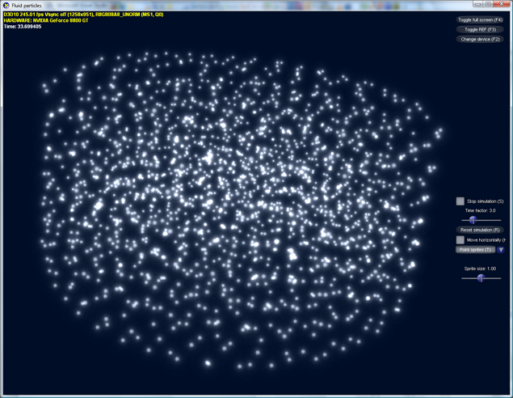

Figure 13: Sprite rendering

Different particle visualisation techniques exist. The most common of them in realtime computer-graphics is billboard rendering of sprites. At every particle position it places a textured rectangle that is always aligned towards the viewer (hence the name billboard). In order to provide a depth effect the size of the rectangles should be proportional to the distance from the viewer and alpha blending may be necessary to achieve visual appealing results.

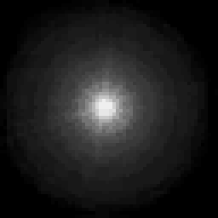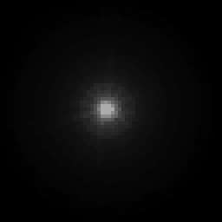

Figure 14: RGB and alpha channel of the particle texture

Two implementations of the sprite renderer where provided: One for Direct3D 9 and one for Direct3D 10. The D3D9 renderer uses the existing sprite render functionality provided by the fixed function pipeline. Therefore, it only must transfer the particle positions into a vertex buffer, set the sprite texture, enable point sprites and specify some additional render state variables, like alpha-enable and point-scale, before it starts rendering with a draw call on a point list.

### Sprites with D3D10

Because in D3D10 the default billboard renderer is gone together with most of the fixed function pipeline, sprite rendering is slightly more complex to implement with it. Like its D3D9 pendant, the D3D10 sprite renderer transfers the particle positions in a vertex buffer and sets the sprite texture. Additionally it calculates position offsets of the four sprite corners relatively to the sprite centre in world space. For this purpose the inverse view matrix is needed to position the sprite corners in a way that aligns the billboards with their front facing towards the camera. During the rendering a geometry shader is invoked that generates two triangles for every input vertex, which represent the billboard rectangle. The triangle vertices are generated by adding the sprite corners to the particle positions in world space and transform the result to clip space afterwards. The associated pixel shader performs a lookup in the sprite texture for every fragment that is generated by the fixed function rasterizer and depth- and blend-states control the composition to the final image.



Figure 15: Billboard rendering with a D3D10 geometry shader

## Isosurface rendering with marching cubes

The goal of the thesis is to simulate water-like fluids and therefore also the visualisation should produce images that look like water. However, good-looking efficient realtime water rendering for particle based simulations is still an open research topic. Since clear water is nearly as transparent as air, most visualisations display only the water surface. Thus, first of all the challenge is to find this free surface. Most current visualisations adopted a concept that is used with grid based fluid simulations: Isosurface rendering.

### The isosurface

The basis for isosurface rendering is a discrete representation of the volumetric density scalar field of the fluid. How such a volume grid of the density can be constructed from a set of fluid particles will be discussed later in this subchapter. The idea is to look at regions with an equal density value (Greek word for equal: ἴσος - isos; hence the names isovalue/isolevel and isosurface). It is assumed that these regions have the form of a 2d surface, an orientable 2-manifold without boundary. Note that this would not be true, if the density function is discontinuous (-> boundaries) or has an equal value in a whole volumetric area (-> 3-manifold with boundary). The isosurface for a small density isovalue is a good approximation of the water surface. In the computer representation of the density field (basically some sort of float array) both the domain and the range are discrete. To avoid problems with volumetric zones of the same value, it is reasonable to define the isosurface as the area between regions where the value is less than the isovalue and regions where it is equal or higher. Thereby even volumetric areas of the same value produce a closed 2d isosurface.

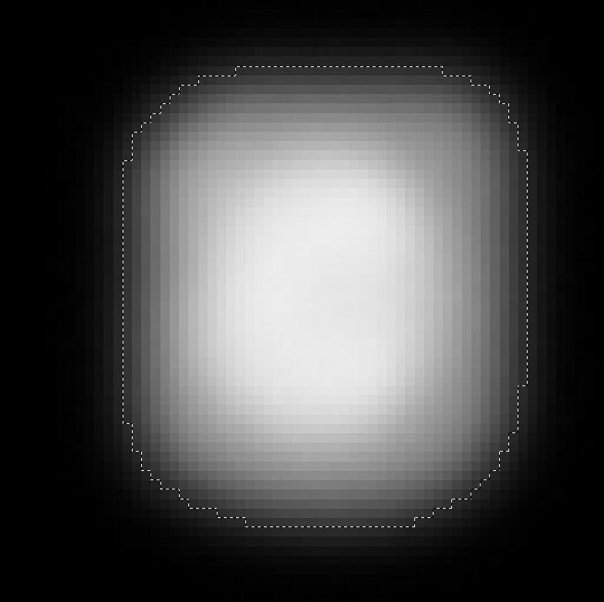

Figure 16: 2d illustration of a discrete isosurface

### Marching cubes

A famous technique to construct a triangle mesh as renderable representation of the isosurface was published in 1987 by Lorensen and Cline [LC87]. The marching cubes algorithm piecewise processes eight density values at a time, which form an imaginary graph in form of a cube. First it checks for each of the 12 edges if it intersects the isosurface. This is the case if one of the connected nodes is less and the other is greater or equal than the isovalue. For every intersection it generates a vertex through linear interpolation of the two node positions, which estimates the position where the field value would exactly equal the isovalue. Then it generates an 8-bit code for the corners of the cube (1 if corner value is below isovalue, 0 otherwise). This code exactly identifies the 256 possible triangle configurations of a cube, which derive from 15 unique combinations trough rotation and reflection. The mesh that is formed by the triangles from all cubes, by design of the algorithm, represents the isosurface without any gaps.

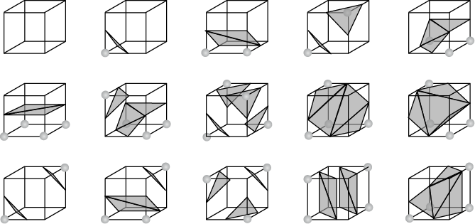

Figure 17: The 15 distinct cube triangle configurations  
Source: Wikimedia commons

### Implementation

The implementation for this thesis was tuned for high performance and thus became slightly more complex than this simple explanation. First of all, additionally to the scalar density field a vector-valued gradient field is used to provide an efficient way to generate normals. Furthermore, a clever implementation of the algorithm should take advantage of the facts that the cube edges share the same corner nodes (inside one cube as well as between adjacent cubes) and the triangles share the same vertices. The current implementation of the marching cubes algorithm, therefore, processes the volume in rows and uses the already calculated information of each cube’s direct precursor, for the 4 shared corners and 4 shared edges (respectively up to 4 shared vertices). Hence, in every step only 4 instead of 8 corners and only 8 instead of 12 edges must be evaluated. Better use of shared information and hence generation of even fewer vertices would only be possible with complex management of already visited corners and edges. This would only be reasonable if the generated mesh is used for much more than one frame (when a speedup in visualisation would overweight the slower mesh construction).



Figure 18: Marching cubes shared corners and edges

The current algorithm first evaluates the 4 new corner nodes and checks if their values are below the isolevel. From the results of the 4 old and 4 new corners it creates the 8-bit key that identifies the topology of the local mesh. First this key is used as index in an edge-table to obtain another key that specifies for each edge if it intersects the isosurface. For all new edges that intersect the isosurface, a vertex, inclusive interpolated position and normal, is generated and stored in a vertex-buffer. Then the same 8-bit key is used as index in a triangle-table to obtain the local vertex indices of the triangles, which are converted to global vertex indices and stored in an index-buffer. The vertex and index buffers are later used in a usual indexed draw call to visualize the generated isosurface mesh.

### Efficient volumetric density field construction

As stated before, marching cubes is intended to work on discrete volumetric scalar fields. In order to use it as surface visualisation technique for particle based simulations, thus, it is necessary to create such a density grid first. For this task the application manages a grid that adapts its size and position to the volume occupied by the fluid particles. Each particle “renders” a footprint of its density into the grid. In the simple version of the algorithm a cubic set of voxels is determined that contains all voxels that may be affected by the density of the particle. For each voxel the density contribution of the particle is approximated by evaluation of the SPH density equation at the voxel centre. This density contribution is added to the related overall density value of the voxel.



Figure 19: Simple contribution of particle density

### Density stamps

A second, more advanced density distribution method uses so called density stamps to avoid the repeated evaluation of the density equation for every particle-voxel interaction. It assumes that the voxels are so small, that the movement of a particle inside a single voxel does not result in a noticeable change in the density distribution among the voxels. The algorithm precomputes a stamp of the density distribution. The stamp is a set of density values for an imaginary set of voxels that is really influenced by a particle. The stamp must only be updated if the smoothing length or the voxel size changes. For density distribution with a stamp, it is only relevant in which voxel the particle is located. The stamp values then are added directly to the corresponding voxels. A slightly sophisticated stamp data structure (which will not be further discussed here) is necessary to access only those voxels that are really influenced by the particle.

|  |  |
| --- | --- |
| Figure 20: Stamp creation | Figure 21: Contribution of particle density with stamp |

### Results

The program component based on the presented algorithm is capable to perform all necessary steps, from filling of the grid to construction and rendering of the mesh, at interactive frame rates. With deactivated simulation, the whole chain can be executed 150 times per second on a single 3.2 GHz CPU (no multithread support) for 1728 particles and a grid voxel-size of 0.9³ (compared to a volume size of ~22³). However, this is a high amount of the total computation time, as the frame rate only drops to 113 frames-per-second (fps) when the simulation is activated too. Especially the voxel-size has a great impact on the computation time: A voxel-size of 1.8³ results in 499 FPS, while only 17 FPS are achieved with a voxel-size of 0.4³. An interesting fact is that the mesh construction via marching cubes does need less time than the fill of the grid: 295 FPS with mesh construction only versus 220 with stamp-based grid-fill only. The actual rendering of the mesh needs nearly no time in comparison, as there is no measureable difference between the FPS of the rendering only and the program doing “nothing” (both ~800 FPS).

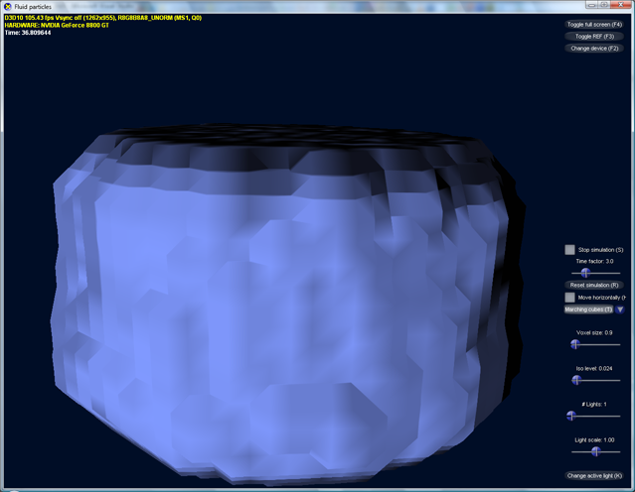

Figure 22: Resulting marching cubes surface visualisation (voxel-size 0.9³)

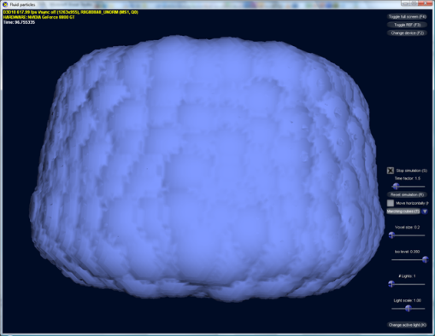

Figure 23: Marching cubes visualisation (voxel-size 0.1³)

### Pros and cons

This shows that the marching cubes algorithm may be an adequate technique for visualisation of static volume datasets, where new isosurface meshes must be constructed only sometimes. As visualisation for the output of a realtime liquid simulation, however, the time needed for the generation of the density grid and the isosurface mesh quickly becomes a bottleneck. Also the visualisation quality remains a problem. Despite the interpolation of intersection positions and normals, the generated meshes still look square-cut. Even with fine-grained voxelisation, which soon results in heavily over-tessellated meshes, the grid-origin or the visualisation remains visible. To name also advantages of marching cubes, a triangle mesh is exactly the sort of geometric model for which realtime 3D-APIs and graphics cards are optimized for. Hence, there is a bunch of techniques that could be used to let the mesh look like a water surface. Sadly, one important optical effect of water, namely refraction, is hard implement with triangle raster graphics.

### Further work

To improve the visual quality of marching cubes based rendering, some mesh-smoothing technique could be used to give the images the smooth and round look that is characteristic for liquids. A great jump in performance could be made if the CPU executed algorithm would be replaced with a GPU pendant. A geometry shader based marching tetrahedra algorithm was presented by Uralsky on the GDC 2006 [Ura06]. An implementation inclusive source code can be found in the actual Nvidia SDK 10. It would not be a problem to combine it with the GPU based density field construction presented in 3.6 to an entirely GPU executed marching cubes visualisation for a particle based liquid simulation.

## GPU-based isosurface ray-tracing

Explicit representations of isosurfaces (like i.e. the triangle meshes of marching cubes) are not the only way to produce visualisations of volumetric data sets. Direct volume rendering (DVR) techniques i.e. project all voxels with different opacities directly on the view plane. In [KW03] Krüger and Westermann demonstrated direct volume rendering that utilizes the high texture sampling performance of modern graphics cards. In contrast to comparable existing solutions that where based on several view-plane aligned slices of 3D-textures, they proposed an algorithm that samples the volume texture along the view rays (volume raycasting). This not only resulted in a DVR implementation, which is more efficient because it skips occluded voxels, it also opened the door for GPU based isosurface ray-casting.

|  |  |
| --- | --- |
| CTWristImage.png  Figure 24: Direct volume rendering of a CT scan with color coding of different densities Source: wikipedia.org | 1.png  Figure 25: Isosurface-raycast renderings Source: [KW03] |

### Isosurface raycasting, basic principle

In principle, the algorithm works as follows: For every pixel of the final image that would show the border of the volume a view ray is calculated (backward ray-tracing). Starting from the entry intersection with the volume border, the data set is being sampled repeatedly at incremental positions along the view ray. The procedure stops when a sample value is found that is greater than the isolevel (or enough opacity has been accumulated, in case of DVR). In this case a refinement operation is invoked that tries to find the best position for the isosurface between the current and the last sampling point, in a binary-search like manner. In the case that no sample greater than the isovalue is found, it is assumed that the ray does not hit the isosurface.

|  |  |
| --- | --- |
| Figure 26: Ray construction | Figure 27: Sampling along the ray |
| Figure 28: Hit refinement | |

### Volume raycasting with pixel shader 2.0

The application discussed in [KW03] implemented all essential parts of the raycast algorithm as shader model 2.0 pixel shader. The restrictions of this earlier API version lead to a multi-pass rendering technique, which relied heavily on the render-to-texture functionality to transfer intermediate results between subsequent rendering passes. The first pass was used to render the back-faces of a bounding box that represents the volume border. Note that the rasterisation of the bounding box creates only fragments for pixels that would result in a ray which really hits the volume (compare Figure 26). The rasterizer interpolates the (3D-) texture space coordinates of the box vertices and the pixel-shader puts them out to a render-target with the dimensions of the final image.

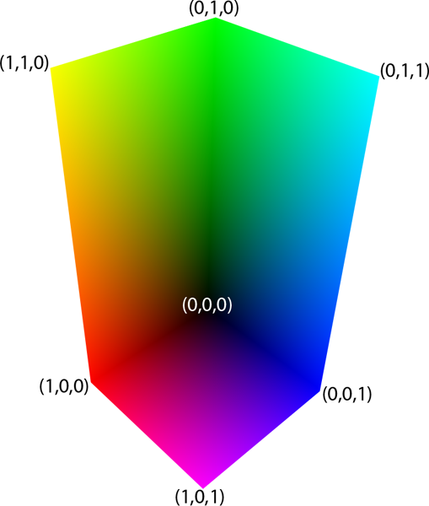

Figure 29: Ray exit texture

In the second pass the front faces of the bounding box are rendered and the texture coordinates are interpolated once again. The invoked pixel-shader uses the normalised device coordinates of the fragment (x, y) to sample the texture that was the render-target of the first pass. The exit- (first pass) and entry (second pass) positions of the ray, presented by the 3D-texture coordinates, are used to calculate (texture space-) ray direction (xyz) and -length (w), which are outputted to the next render-target. This information is sampled and used in pass 3 and all odd following passes, which perform the actual raycasting. Again, they render only the front-faces and use the ray-entry (still: interpolated per-vertex texture coordinates) and ray-direction to calculate volume sampling points with the parameterized ray equation: . The step parameter is calculated from the step-size and the number of already performed steps and is stored in a constant, to be available in further raycast passes. When the volume texture’s size is not equal on every dimension, the step size must be calculated individually for each pixel. This is because the transformation of the step-size from world to texture space (which ranges only from [0, 0, 0] to [1, 1, 1]) leads to different lengths depending on the ray direction, in this case.



Figure 30: Reason of per pixel step-size

Each raycast pass collects M samples from the volume texture. In case of direct volume rendering the samples are accumulated and the opacity is raised. In case of isosurface rendering, the sampling is done back-to-front in every pass (while execution order of the passes remains front-to-back) and only the last position where the isovalue was reached is kept. Thereby the first sample (in direction of the ray) that matches the isovalue is found. After every raycasting pass, an intermediate pass checks if the stop criterion (enough density reached / isovalue reached / exit passed) is met. If so, it sets the z-buffer to its maximum value, so that the early z-test prevents all further passes for this pixel.

Luckily the capabilities of the pixel-shader API have been greatly improved since 2003. The shader model 4.0, which was used for the isosurface ray-tracing component of this project, offers some pixel-shader features that make the implementation of the raycast algorithm far more intuitive and improve its performance. First of all, the discard command, which allows the pixel-shader to “kill” the current fragment at any time, makes the intermediate stop pass completely obsolete. Second the (theoretically) unlimited length of shader-code and the branching features (introduced with SM 3.0, but greatly improved in 4.0) allow the execution of the whole ray-tracing (this time we will cast secondary rays too) in a single pass. This eliminates the extra texture sampling that was needed before to transfer information between subsequent passes. The only extra pass that remains, is the initial determination of the exit point via rendering of the back-faces, because it is still the most promising way to that.

With this greater flexibility in the pixel-shader it is possible to extend the ray-casting algorithm to simple ray-tracing. Ray-tracing is the basis for the simulation of some important water related optical phenomena in the presented visualisation technique. Therefore, we will first discuss the optical characteristics of water and how ray-tracing could be used to simulate them, before we get into the details of the shader program.

### Optical characteristics of water surfaces

TODO: first water photos

As stated some chapters earlier, clear water is quite transparent on short distances and so it makes sense to do not render the inner of the water volume at all. The surface of the water, however, has a strong influence on its overall look. Two optical phenomena occur when light hits the border between water and air: Reflection and refraction. Dense materials, such as water, have a higher index of refraction like less dense materials. The refractive index is a measure for how much the medium reduces the speed of waves (i.e. light) that travel through it. In a medium with refraction index for example, light travels only with half of its speed in vacuum (vacuum: ). Note that the velocity of propagation in a medium, and therefore also the refractive index, depends on the type of radiance and on the particular wavelength. When a ray of light arrives at a border where the refractive index changes, a part of the light is reflected back into the current medium and another part passes the barrier, but not without a change of direction. To describe the interaction of light with such a surface, three values must be assessed: The direction of the reflection ray, the direction of the refraction ray and the ratio of reflected versus refracted amount of light.

### Law of reflection

The first is the simplest one. The law of reflection states that incoming ray, reflected ray and surface normal lie in the same plane and that the angle between incoming ray and normal is the same as between reflection and normal.



Figure 31: Law of reflection

In 3D computer graphics we treat directions mostly as normalised three-component vectors. Hence, the law of reflection has to be formulated in vector notation. A common technique is to define the reflection vector as sum of the scaled light- and normal vectors:

|  |  |  |
| --- | --- | --- |
|  |  |  |



Figure 32: Vector form of reflection

Taking into account that the dot-product of two normalised vectors equals the cosine of the angle between them, Figure 32 results in the following equation for the reflection direction:

|  |  |  |
| --- | --- | --- |
|  |  |  |

### Snell’s law

Also the refraction ray lies in the same plane as incoming ray and normal. In contrast to reflection, however, the direction of refraction depends on the refraction indices (therefore the name) of the participating materials. It is described by Snell’s law (named after its discoverer, Willebrord Snellius), which is also called law of sines or law of refraction:

|  |  |  |
| --- | --- | --- |
|  |  |  |

: angle between incoming ray and surface normal  
: angle between refraction ray and negative surface normal  
: light velocity in first medium  
: refraction index of first medium  
Note: refraction direction is named , from transmission, to not be confused with



Figure 33: Snell's law

The index of refraction depends on the wavelength (except for vacuum), which generally results in different refraction directions for different light colors. This phenomenon is called dispersion and can be observed at optical prisms or rainbows. Because the effect is barely noticeable in our scenario, we will ignore it and treat the refraction indices as constant.

The careful reader may have noticed that there is not always a solution to Snell’s equation. When light hits a material with lower index of refraction than the current, the term can become greater than one, which is not in the domain of the arcsine function. In this case the ray undergoes total internal reflection, meaning all light is reflected and nothing is refracted at all. This coincides with the later equations, which describe how much light is reflected and refracted. In the special case when the term becomes exactly one, is called the critical angle and the refracted light travels directly along the surface.

As before, Snell’s law must be formulated in vector notation, before it can be used in our shader program. We can use the technique from equation (3.1) here too and write the refraction direction as sum of the scaled incident- () and normal- () vectors. The following drawing illustrates this:



Figure 34: Vector form of refraction

First we search for , which is the factor must be scaled with. From geometry we know must equal . is normalised therefore . Snell’s law says the quotient of the sines equals the inverse quotient of the refraction indices, so we get:

|  |  |  |
| --- | --- | --- |
|  |  |  |

To determine we subtract x and y from :

|  |  |  |
| --- | --- | --- |
|  |  |  |

can be obtained through scaling of :

|  |  |  |
| --- | --- | --- |
|  |  |  |

can be acquired from . Application of Snell’s law and consequent use of the rule lead to the result:

|  |  |  |
| --- | --- | --- |
|  |  |  |

Combining equations (3.1), (3.4), (3.5), (3.6) and (3.7) finally leads to the refraction direction in vector form:

|  |  |  |
| --- | --- | --- |
|  |  |  |

### Fresnel term

We now know both rays on which the light from the incoming ray can be split, but we still have to decide how it is distributed among the two directions. This distribution is given by the reflection coefficient and the transmission coefficient . It is sufficient to define only , because zero absorption is assumed (). Without going to deep into optics, it should been remarked that the reflectance (intensity reflection coefficient) is the square of the amplitude reflection coefficient: . The intensity of the reflected light depends on its polarisation relative to the plane in which the three rays lie. The reflection coefficient for light polarised parallel to the plane (p-polarised) is called . The one for light polarised perpendicular to the plane (s-polarised) is called . They are given by the Fresnel equations (deduced by Augustin-Jean Fresnel):

|  |  |  |
| --- | --- | --- |
|  |  |  |
|  |  |  |

is still acquired from with Snell’s law. Because these equations are undefined for this limit applies:

|  |  |  |
| --- | --- | --- |
|  |  |  |

The following plot illustrates both coefficients once for and once for :

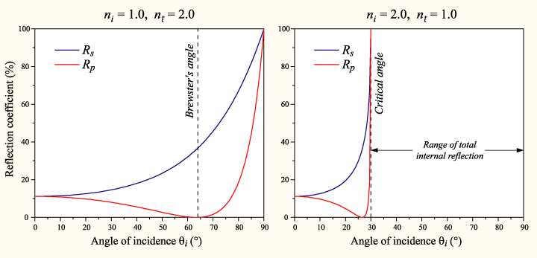

Figure 35: Fresnel reflection coefficients  
Source: Wikimedia commons

For unpolarised light (containing an equal mix of s- and p-polarisations) the reflection coefficient is:

|  |  |  |
| --- | --- | --- |
|  |  |  |

According to [NVF02], substitution of (3.3), (3.9) and (3.10) into (3.12) yields:

|  |  |  |
| --- | --- | --- |
|  |  |  |

It can be simplified by defining and as:

|  |  |  |
| --- | --- | --- |
|  |  |  |

This results in an equation, which is known as “Fresnel term” in computer graphics:

|  |  |  |
| --- | --- | --- |
|  |  |  |

Note: Different formulations of the Fresnel term exist.  
Each defines and slightly different.

In the actual shader program, however, (3.15) is approximated by a computational less expensive polynomial:

|  |  |  |
| --- | --- | --- |
|  |  |  |

Figure 36 shows how far this approximation is from equation (3.15) and from the simplest approximation :

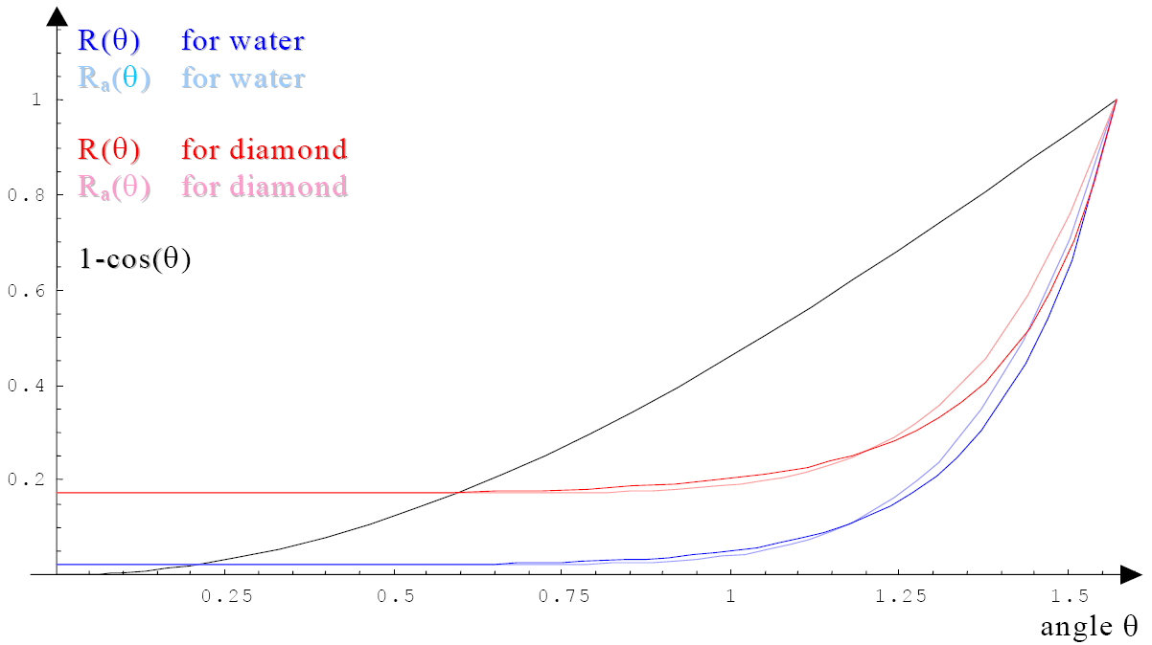

Figure : Fresnel term approximation quality  
Source: [NVF02]

### Description of the overall effect

Law of reflection, law of refraction and Fresnel term altogether describe how the optical behaviour of the water surface is simulated at the first intersection with the view ray. The visualisation thereby utilises the general interchangeability of light ray and view ray in lighting calculations. Water has a higher index of refraction than air and so Snell’s law bends the refraction of the view ray towards the negative surface normal. Trough the mostly round shape of the surface, the water body, therefore, appears like a magnifying glass. Due to the Fresnel term, reflections are mostly visible at the silhouette, where the view ray is almost orthogonal to the normal. At the inside the refractions prevail. Figure 37 illustrates directions and intensities of the involved rays, when light hits a water surface from air direction. Figure 38 does the same for light from water direction. For backward raytracing the light direction simply can be exchanged with the view direction.

|  |  |
| --- | --- |
| Figure 37: Light hits surface from air direction | Figure 38: Light hits surface from water direction |

The following photographs show the discussed effects at real surfaces.

TODO: sharp bend photo, magnifying water photo, Fresnel photo

Let us now slowly come back to the shader program. What happens with calculated secondary rays? The reflection ray (or better: its direction) is used to perform a texture lookup in an environment map. If the same would be done with the refraction ray, we would only visualise the “front-face” of the water body. This would not be physical plausible, would not result in an authentic look and besides, it would be possible with conventional raster graphics just as well. However, the visualisation component was called ray-tracer and not ray-caster. This is, because actually the refraction ray is getting traced too. In a second ray-cast step, the exit-intersection of the view ray with the isosurface is being identified. When the water surface is closed and no other object is contained inside, it is clear that such a second intersection must exist. This time, the first position is searched where the volume exhibits a density value *below* a certain, slightly higher isovalue.

When the second intersection is found, in principle the same steps as for the first must be performed. The internal reflections, however, would lead to a great number of additional ray-casting steps. Hence, a simplification is made and only the refraction that leads to the exit-ray is been calculated. The colour value for the exit-ray is sampled directly from the environment map. For that purpose, neither the law of reflection, nor the Fresnel term has to be considered at the second intersection. Although this is in no way physical plausible, it leads to optically appealing results. The “back-face” of the water surface is visible and the magnifying effect functions as desired. Without the second refraction, the transmitted view ray would be redirected way too much. The missing internal reflections do not annoy, because our brain could not process them anyway. The following figure shows all calculated rays:



Figure 39: Calculated rays

What brings us into trouble is the special case of total internal reflection. When there is simply no refraction possible, we are still forced to reflect. To stop the ray-tracing nonetheless, the reflected ray is also directly used to sample the environment map. The resulting effect still looks rather plausible to the user. The two environment lookups mark the end of the ray-tracing activity. No additional intersections are calculated, even if in principle the isosurface could be hit much more often than two times.

## GPU-based volumetric density field construction

## Rendering optical characteristics of water

## Results

## Improvements and alternatives

comparison of the pros and cons of different techniques

empty space skipping

grid-generation in homogenious device space

# Conclusion

# Appendix

## References

**[APK07] Adams, et al. 2007.** Adaptively Sampled Particle Fluids. *Proceedings of the 2007 SIGGRAPH conference.* 2007.

**[AIY04] Amada, et al. 2004.** Particle-Based Fluid Simulation on GPU. *ACM Workshop on General-Purpose Computing on Graphics Processors.* 2004.

**[BT07] Becker and Teschner. 2007.** Weakly compressible SPH for free surface flows. *Proceedings of the ACM SIGGRAPH Symposium on Computer Animation.* 2007, pp. 63-72.

**[BM07] Bridson and Müller-Fischer. 2007.** Fluid simulation. *SIGGRAPH 2007 course notes.* 2007.

**[BE02] Burgess and Elst, van. 2002.** MAS209: Fluid Dynamics. *Course Material.* 2002.

**[CHJ03] Co, Hamann and Joy. 2003.** Iso-splatting: A Point-based Alternative to Isosurface Visualisation. *Computer Graphics and Applications, 2003. Proceedings.* 2003, pp. 325-334.

**[CEL06] Colin, Egli and Lin. 2006.** Computing a null divergence velocity field using smoothed particle hydrodynamics. *Journal of computational physics.* 2006, 217, pp. 680-692.

**[GM77] Gingold and Monaghan. 1977.** Smoothed particle hydrodynamics: theory and application to non-spherical stars. *Royal Astronomical Society, Monthly Notices.* 181, 1977, pp. 375-389.

**[GPGPU]** GPGPU.org. [Online] http://www.gpgpu.org.

**[Hei07] Heinecke. 2007.** Physikalische Rauchsimulation auf Partikelbasis in Echtzeit mit der PhysX-Engine. [ed.] Technische Universität Dresden. [Minor thesis]. 2007.

**[KW06] Kipfer and Westermann. 2006.** Realistic and interactive simulation of rivers. *ACM International Conference Proceeding Series.* 2006, 137.

**[KC05] Kolb and Cuntz. 2005.** Dynamic Particle Coupling for GPU-Based Fluid Simulation. *Proc. 18th Symposium on Simulation Technique.* 2005, pp. 722-727.

**[KW03] Krüger and Westermann. 2003.** Acceleration Techniques for GPU-based Volume Rendering. *Proceedings of the 14th IEEE Visualisation.* 2003, p. 38.

**[LC87] Lorensen and Cline. 1987.** Marching cubes: A high resolution 3D surface construction algorithm. *Proceedings of the 14th annual conference on Computer graphics and interactive techniques.* 1987, pp. 163-169.

**[Luc77] Lucy. 1977.** A numerical approach to the testing of the fission hypothesis. *Astronomical Journal.* 82, 1977, pp. 1013-1024.

**[Mon05] Monaghan. 2005.** Smoothed particle hydrodynamics. *Reports on Progress in Physics.* 2005, 8.

**[Mon92] —. 1992.** Smoothed particle hydrodynamics. *Annual review of astronomy and astrophysics.* 1992, 30, pp. 543-574.

**[MCG03] Müller, Charypar and Gross. 2003.** Particle-Based Fluid Simulation for Interactive Applications. *Proceedings of 2003 ACM SIGGRAPH Symposium on Computer Animation.* 2003, pp. 154-159.

**[MST04] Müller, et al. 2004.** Interaction of Fluids with Deformable Solids. *Computer Animation and Virtual Worlds.* 2004, 15, pp. 159 - 171.

**[Pap99] Papanastasiou, Georgiou and Alexandrou. 1999.** *Viscous Fluid Flow.* s.l. : CRC Press, 1999. ISBN13: 9780849316067.

**[THM03] Teschner, et al. 2003.** Optimized Spatial Hashing for Collision Detection of Deformable Objects. *Proceedings of VMV'03.* 2003, pp. 47-54.

**[Ura06] Uralsky. 2006.** Practical Metaballs and Implicit Surfaces. *Game Developers Conference 2006 Presentation.* 2006. http://developer.nvidia.com/object/dx10-practical-metaballs.html.

**[WND]** wikipedia.org. *Navier-Stokes equations/Derivation.* [Online] [Cited: 03 10, 2008.] http://en.wikipedia.org/w/index.php?title=Navier-Stokes_equations/Derivation&oldid=177609104.

## Glossary

## 

Eulerian model 4

Lagrangian model 4

Navier-Stokes equations 3

smoothed particle hydrodynamics 4

Smoothed particle hydrodynamics 12

## Derivation of the gradient and Laplacian of the smoothing kernels

Used calculation rules:

Gradient (of a scalar valued function):

Laplacian (of a scalar valued function; sometimes also written or ):

Chain rule:

Product rule:

Gradient and Laplacian of :

with: ,

Gradient of :

Gradient and Laplacian of :